POLICE STATION DATABASE SCHEMA SCOPE DOCUMENTATION

Scope: This police station database consists of two entities which are police and criminals and then under each entity there are different features that satisfies the requirements that i needed to store in the database.

The schema stores the information about different police people who work in different stations and the criminals who got arrested and based on which crime they got arrested along with under which category does crime comes under.

The police are identified based on their rank(status) which is unique for each person.

ENTITIES

POLICE

CRIMINALS

UNDER FIRST ENTITY

There are three features which comes under this entity

Police details

1. Policeid (PK) - it is the primary key

2. name

3. Phonenumber (UK)

4. dob

5. city

6. Address

7. gender

8. policestatusid(FK)- it is the foreign key which is referenced from the policestatus table.

9. stationid (FK) - it is the foreign key which is referenced from the station table.

POLICE STATUS

1. policestatusid (PK) - it is the primary key

2. policestatusname (UK) - it is the unique key

3. police income

4. description

STATION INFO

1. stationid (PK)

2. stationname

3. stationcity

4. stationphonenumber(UK)

5. address(UK)

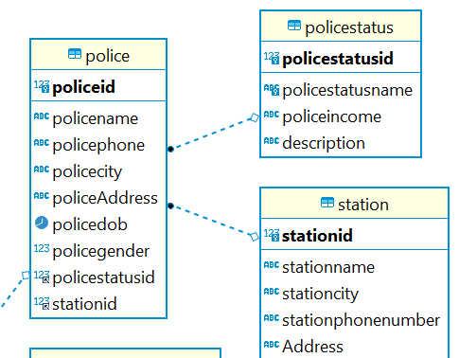

UNDER SECOND ENTITY

There are four features which comes under this entity

CRIMINAL INFO

1. criminalid (PK)

2. criminal name

3. criminal phno(UK)

4. criminal city

5. homeaddress

6. DOB

7. gender

2. CRIMES

1. crimesid (PK)

2. Crimename

3. crimecategory

3. CRIME INCIDENTS

1. incidentid (PK) - it is the primary key

2. Policeid (FK) - it is the foreign key referenced from police table

3. Criminalid (FK) - it is the foreign key referenced from the criminal table

4. Crimesid (FK) - it is the foreign key referenced from the crimes table.

5. Incidentdate

6. incidentoccuredlocation

4. gender

1. genderid (PK)

2. male boolean

3. female boolean

Under each feature there are different attributes which store different data which is helpful to identify a criminal based on the crime he did.

